1. Write a program to check if a number is positive, negative, or zero.

Input : take the one value as the input let say n

Process : if n is greater than 0 it is positive and

If nis less than 0 negative and n equal to 0 then zero

Output : tells the given number is positive or zero

Program:

#include <stdio.h>

int main()

{

int n;

scanf("%d",&n);

if(n>0)

printf("positive number");

else if(n<0)

printf("negative");

else

printf("zero");

}

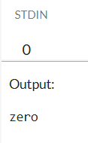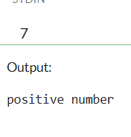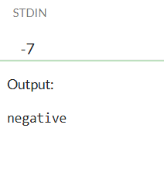

2. Write a program to find the largest among three numbers.

Input: take three numbers as the input lets say a,b,c

Process: if a>b and a>c then a is largest

Else if b>c

Then b is the largest

Else

C is the largest number among three

Output : largest among the three numbers

Program:

#include <stdio.h>

int main()

{

int a,b,c;

scanf("%d%d%d",&a,&b,&c);

if(a>b && a>c)

printf("a is the largest among the three");

else if(b>c)

printf("b is the largest number");

else

printf("c is the largest number");

}

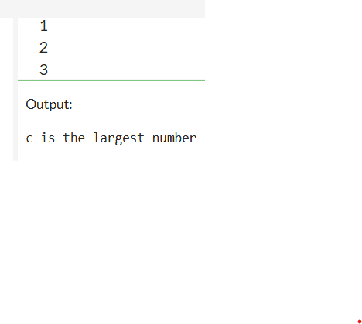

3. Write a program to check if a year is a leap year.

Input : take a any random year as an input

Process: if the year is excalty divisible by 4 and 400 and not by 100 then the given year is the leap year

Output: if the given is leap year or not

Program:

#include <stdio.h>

int main()

{

int year;

scanf("%d",&year);

if(year%4==0 && year%400==0 || year%100!=0)

printf("leap year");

else

printf("not an leap year");

}

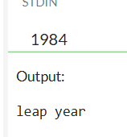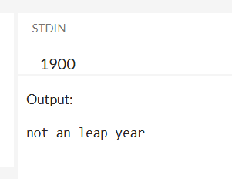

4. Write a program to check whether a character is a vowel or consonant.

Input : take character as an input lets say a

Process:

If a equal to a or e or o or i or u

Output : given letter is consonant or vowel

Program:

#include <stdio.h>

void main()

{

char letter;

scanf(" %c", &letter);

if (letter == 'a' || letter == 'e' || letter == 'i' ||

letter == 'o' || letter == 'u')

printf("'%c' is a vowel.\n", letter);

else

printf("'%c' is a consonant.\n", letter);

}

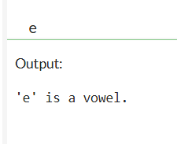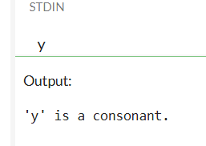

5. Write a program to assign grades based on marks.

|  |  |
| --- | --- |
| Input: | Student's marks (an integer between 0 and 100) |
| Process: | Check the range of marks and assign the corresponding grade |
| Output: | The grade (e.g., A, B, C, D, F) |

Program:

#include <stdio.h>

void main() {

int marks;

scanf("%d", &marks);

if (marks >= 90)

printf("Grade: A\n");

else if (marks >= 80)

printf("Grade: B\n");

else if (marks >= 70)

printf("Grade: C\n");

else if (marks >= 60)

printf("Grade: D\n");

else

printf("Grade: F\n");

}

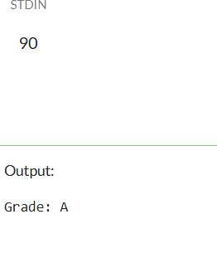

6. Write a program to check whether a number is divisible by 5 and 11.

|  |
| --- |
| Input: A number (integer) |
| process: Check if the number is divisible by both 5 and 11 |
| output: Message stating whether it is divisible by both or not |
|  |

|  |  |
| --- | --- |
|  |  |
|  |  |
|  |  |
| Program:  #include <stdio.h>  void main()  {  int number;      scanf("%d", &number);    if (number % 5 == 0 && number % 11 == 0) {  printf("%d is divisible by both 5 and 11.\n", number);  } else {  printf("%d is NOT divisible by both 5 and 11.\n", number);  }    } |  |

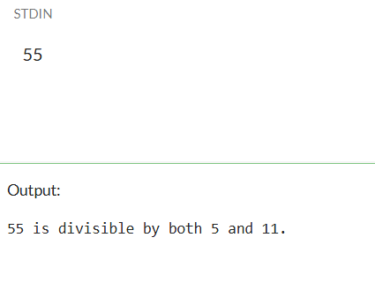

7. Write a program to find the absolute value of a number.

|  |  |
| --- | --- |
| Input: | An integer (positive or negative) |
| Process: | If number is negative, multiply by -1 |
| Output: | The absolute (non-negative) value of number |

Program:

#include <stdio.h>

void main() {

int number, absolute;

printf("Enter an integer: ");

scanf("%d", &number);

if (number < 0) {

absolute = -number;

} else {

absolute = number;

}

printf("The absolute value of %d is %d.\n", number, absolute);

}

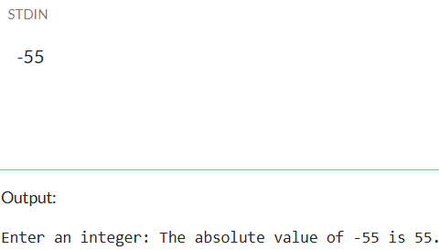

8. Write a menu-driven program to perform +, -, *, / operations.

|  |  |
| --- | --- |
| Input: | Two numbers and a menu choice for the operation |
| Process: | Perform the selected operation using if-else or switch |
| Output: | Result of the operation (sum, difference, product, or quotient) |
| Program:  #include <stdio.h>  void main() {  int choice;  float num1, num2, result;        scanf("%d", &choice);      scanf("%f", &num1);    scanf("%f", &num2);    switch(choice) {  case 1:  result = num1 + num2;  printf("Result: %.2f + %.2f = %.2f\n", num1, num2, result);  break;  case 2:  result = num1 - num2;  printf("Result: %.2f - %.2f = %.2f\n", num1, num2, result);  break;  case 3:  result = num1 * num2;  printf("Result: %.2f * %.2f = %.2f\n", num1, num2, result);  break;  case 4:  if (num2 != 0) {  result = num1 / num2;  printf("Result: %.2f / %.2f = %.2f\n", num1, num2, result);  } else {  printf("Error: Division by zero is not allowed.\n");  }  break;  default:  printf("Invalid choice! Please choose between 1 and 4.\n");  }    } |  |

9. Write a program to find roots of a quadratic equation.

10. Write a program to find the number of digits in a number.

|  |  |
| --- | --- |
| Input: | An integer number (positive or negative) |

|  |  |
| --- | --- |
| Process: | Count how many times you can divide the number by 10 |

|  |  |
| --- | --- |
| Output: | Total number of digits in the number |
| Program:  #include <stdio.h>  int main() {  int n, count = 0,r;  int on;      scanf("%d", &on);    n=on;  while(n>0)  {  r=n%10;  n=n/10;  count++;  }  printf("%d",count);      } |  |